**final.shop.fe12@gmail.com**

**$1q2w3e4R**

**FE12 Final Project**Made by Hands Online Shop

1. Technology stack:

* **React** as UI Library  
  Using only functional components & hooks
* **React Router**
* **Redux** as state manager  
  Watching store changes via useSelector & useDispatch
* **MongoDB** as database
* **Formik** for handling forms
* **Styled Components** for styling
* **Eslint + prettier** for code linting

2. Project file structure

client  
 - node_modules  
 - public  
 - src   
 - components  
 - Example  
 Example.js  
 Example.test.js  
 - UI  
 - pages  
 home.js  
 catalog.js  
 - store  
 - actions  
 - types  
 - reducers  
 configureStore.js

3. Components  
**Button**  
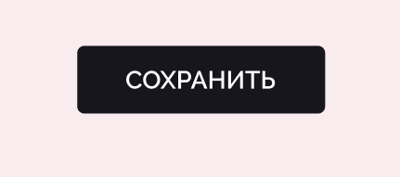

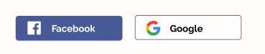

Props:   
 onClick: Func  
 text: string

**Input**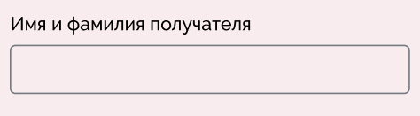

Props:  
 onChange: Func,  
 label: string  
 placeholder: string

**Header**

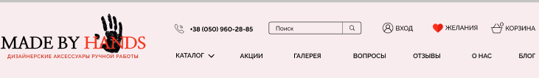

**Navigation**

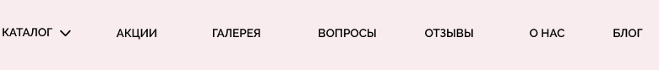

**NavigationDropdown**

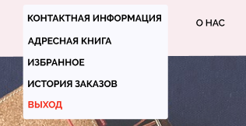

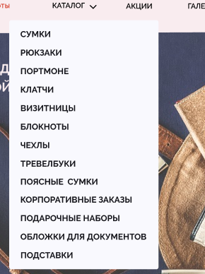

**Search**

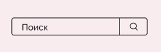

**SectionTitle**

 

**Slider**

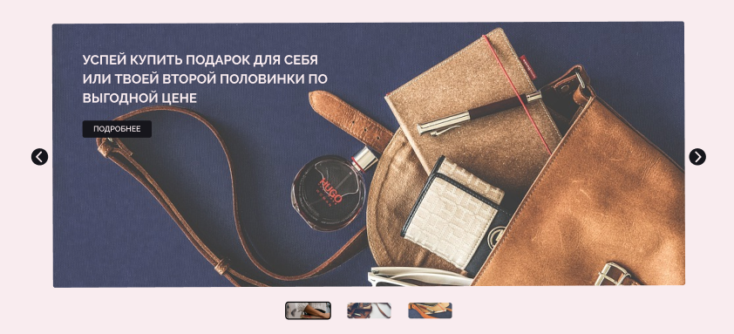

**SliderItem**



**ProductsCarousel**

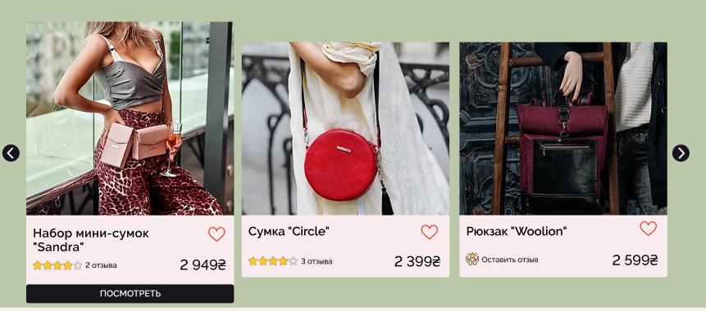

**Preferences**



**PopularCategories**

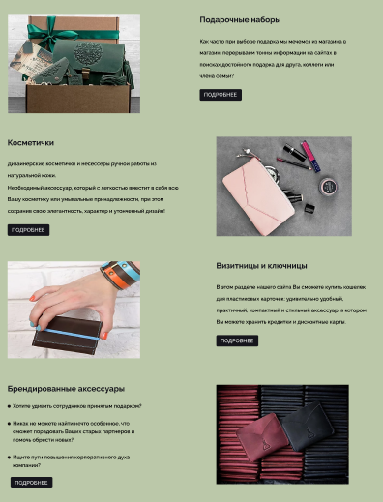

**CategoryItem**



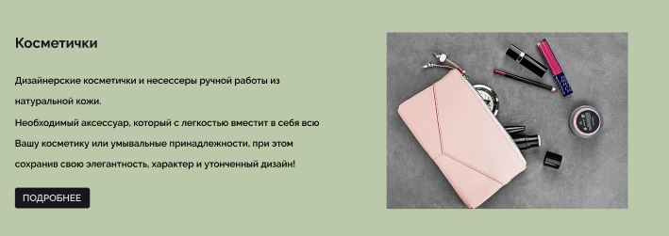

**Footer**

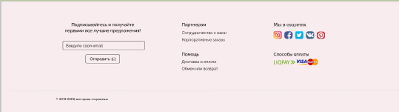

**SubscribeForm**

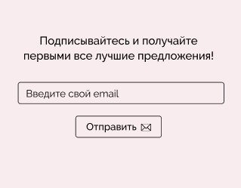

**FooterSocial**

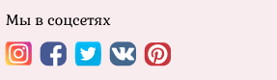

**LoginForm / RegisterForm**

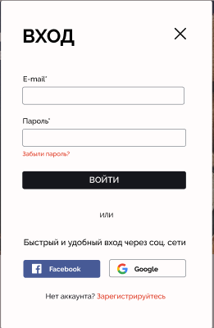 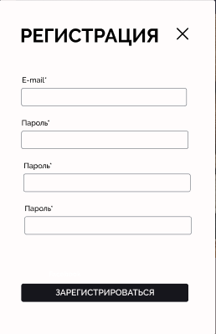

**Catalog**

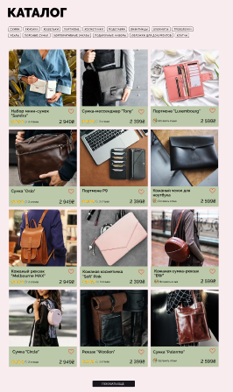

**ProductThumb**



**ProductRating**



**RatingStar**



**FavoriteButton**



**FilterCheckList**

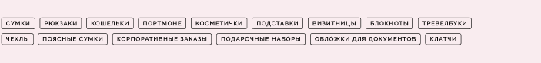

**FilterChekItem**

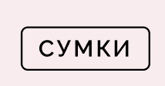

**ProductDeatails**



**ProductDetailsParameters**



**ProductDetailsColors**

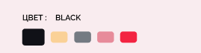

**ProductDetailsCarousel**

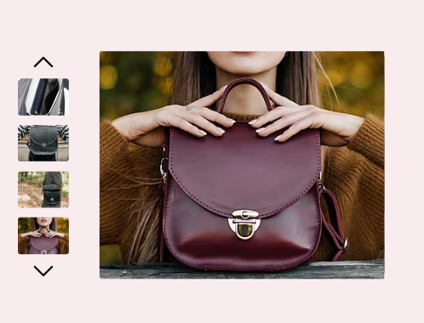

**CartList**

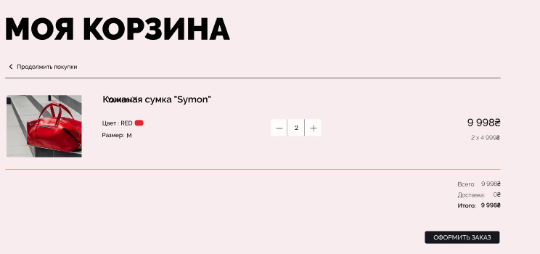

**CartItem**

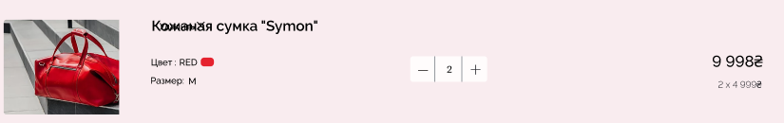

**CartItemThumb**

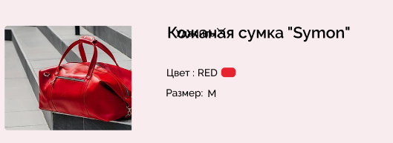

**CartItemCounter**

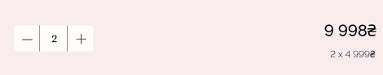

**CartListSummary**

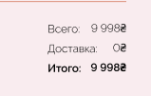

**Checkout**

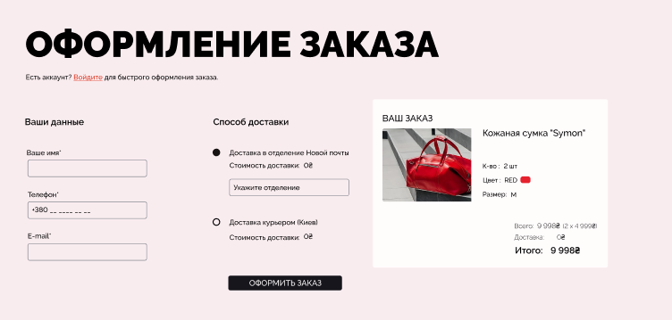

**CheckoutForm**

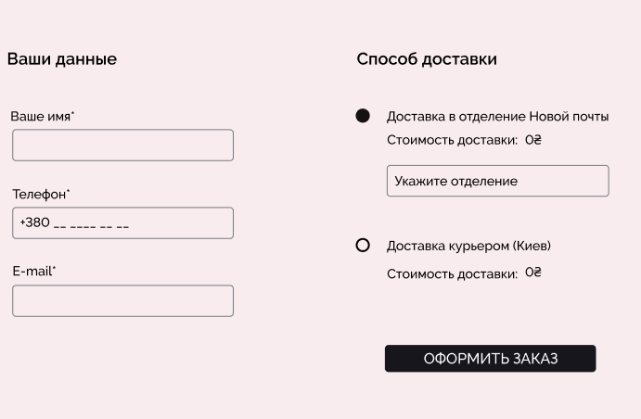

**CheckoutList**

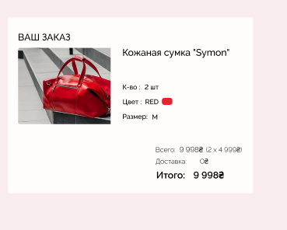

**CheckoutConfirm**



**UserCabinet**

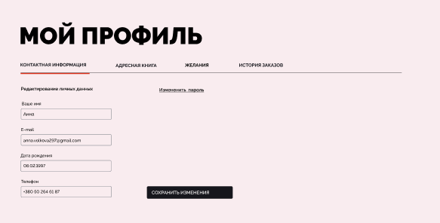

**EditInfoForm**

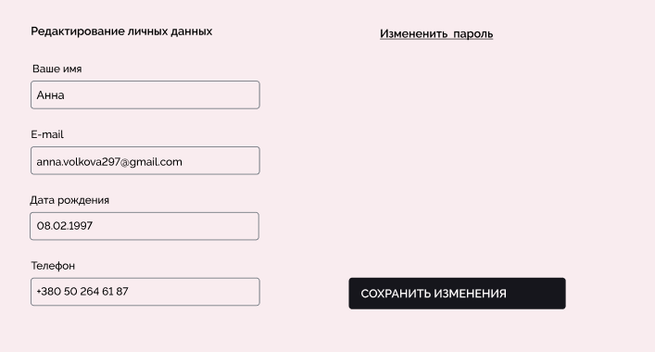

**AddressForm**

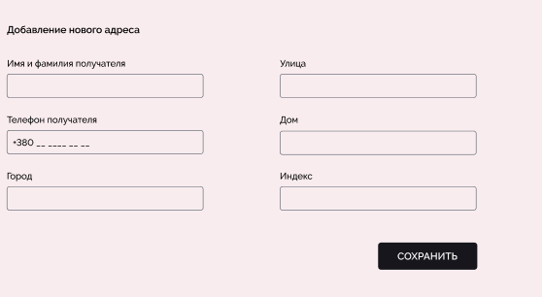

**AddressList**

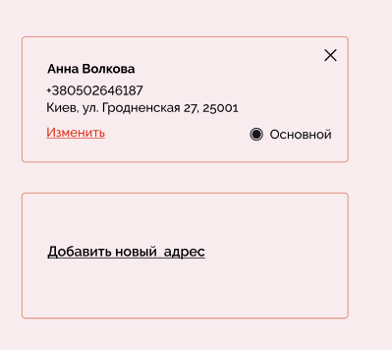

**FavoritesList**

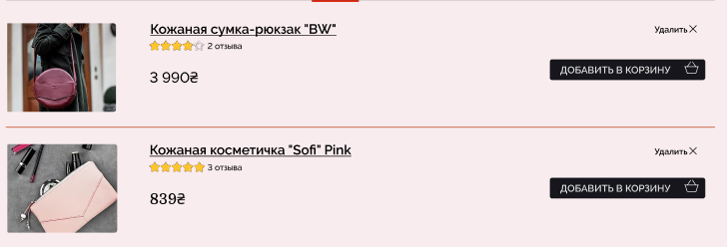

**FavoritesItem**

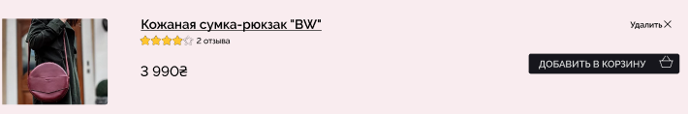

**OrderList**

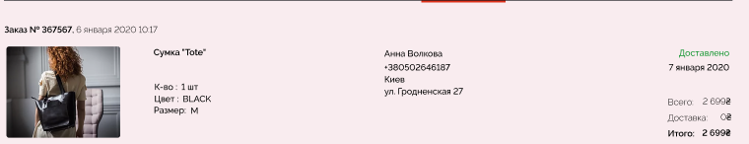

**OrderListItem**

